Programming Assignment #2. Develop application that used stack or a queue ADT with Exception handling and possible test driver.

Main objective is to use inheritance as a part of OOA in ADT implementation. More specifically, now your improved ADT would have inherited additional features like use of exceptions implemented using corresponding interface. Project includes Application to use ADT, ItemType class, ADT itself, and corresponding Interface and exceptions that would enforce via interface a safe use of deque method (when attempting to remove item from the empty queue).

This project in an enhancement of the previous one. Try to reuse as much code as possible from the Project #1. For additional help besides our current textbook, you may see Dale’s Object-Oriented Data Structures textbook used in our CS304 course

Class diagram (use ItemType instead of generics <T>):

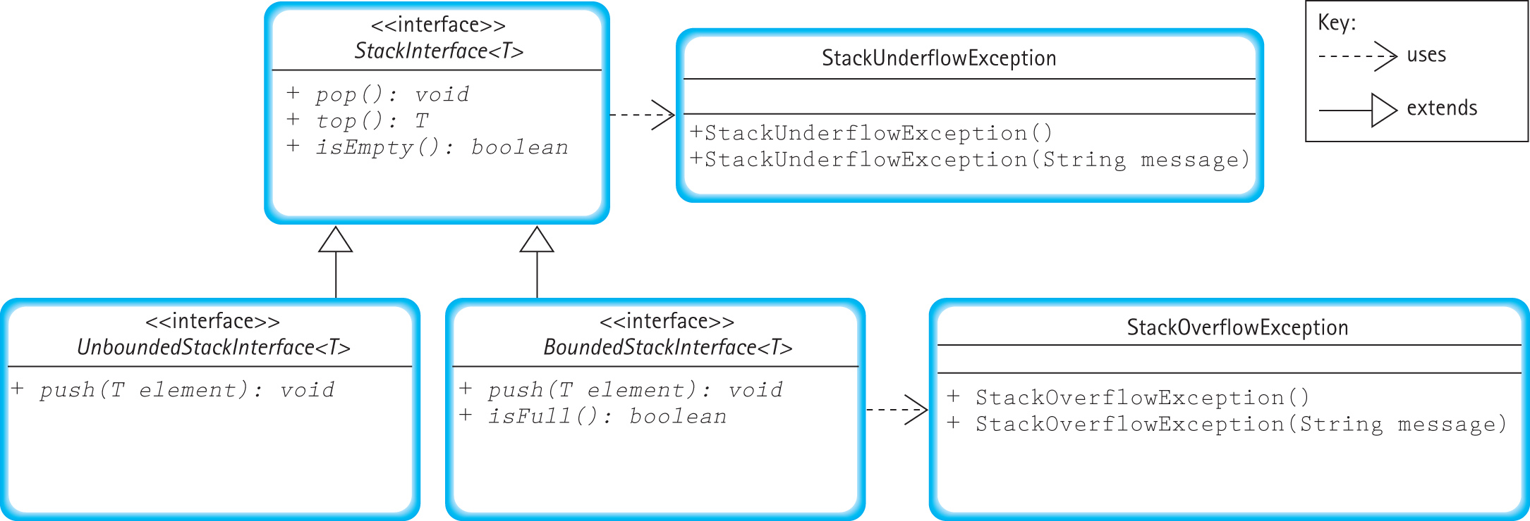

New mandatory components:
- Main function has try/catch blocks
- Use of interfaces
- Use of exceptions

Optional features:
- use input data file and output file for testing
- provide full unit test functionality at least for one function
- use bounded version of ADT.

Possible additional enhancement could be use of simple Test Driver (or modification of your Application) to run unit test for at least one method using test data.

All those optional/extra/additional will be used in the Final project. Make sense to try some of them now to simplify future development.

Deliverables: .java, .class, data (optional) and readme files (from 11 to 15 in total)
Readme file has to include relative to your project UML class diagram.

